**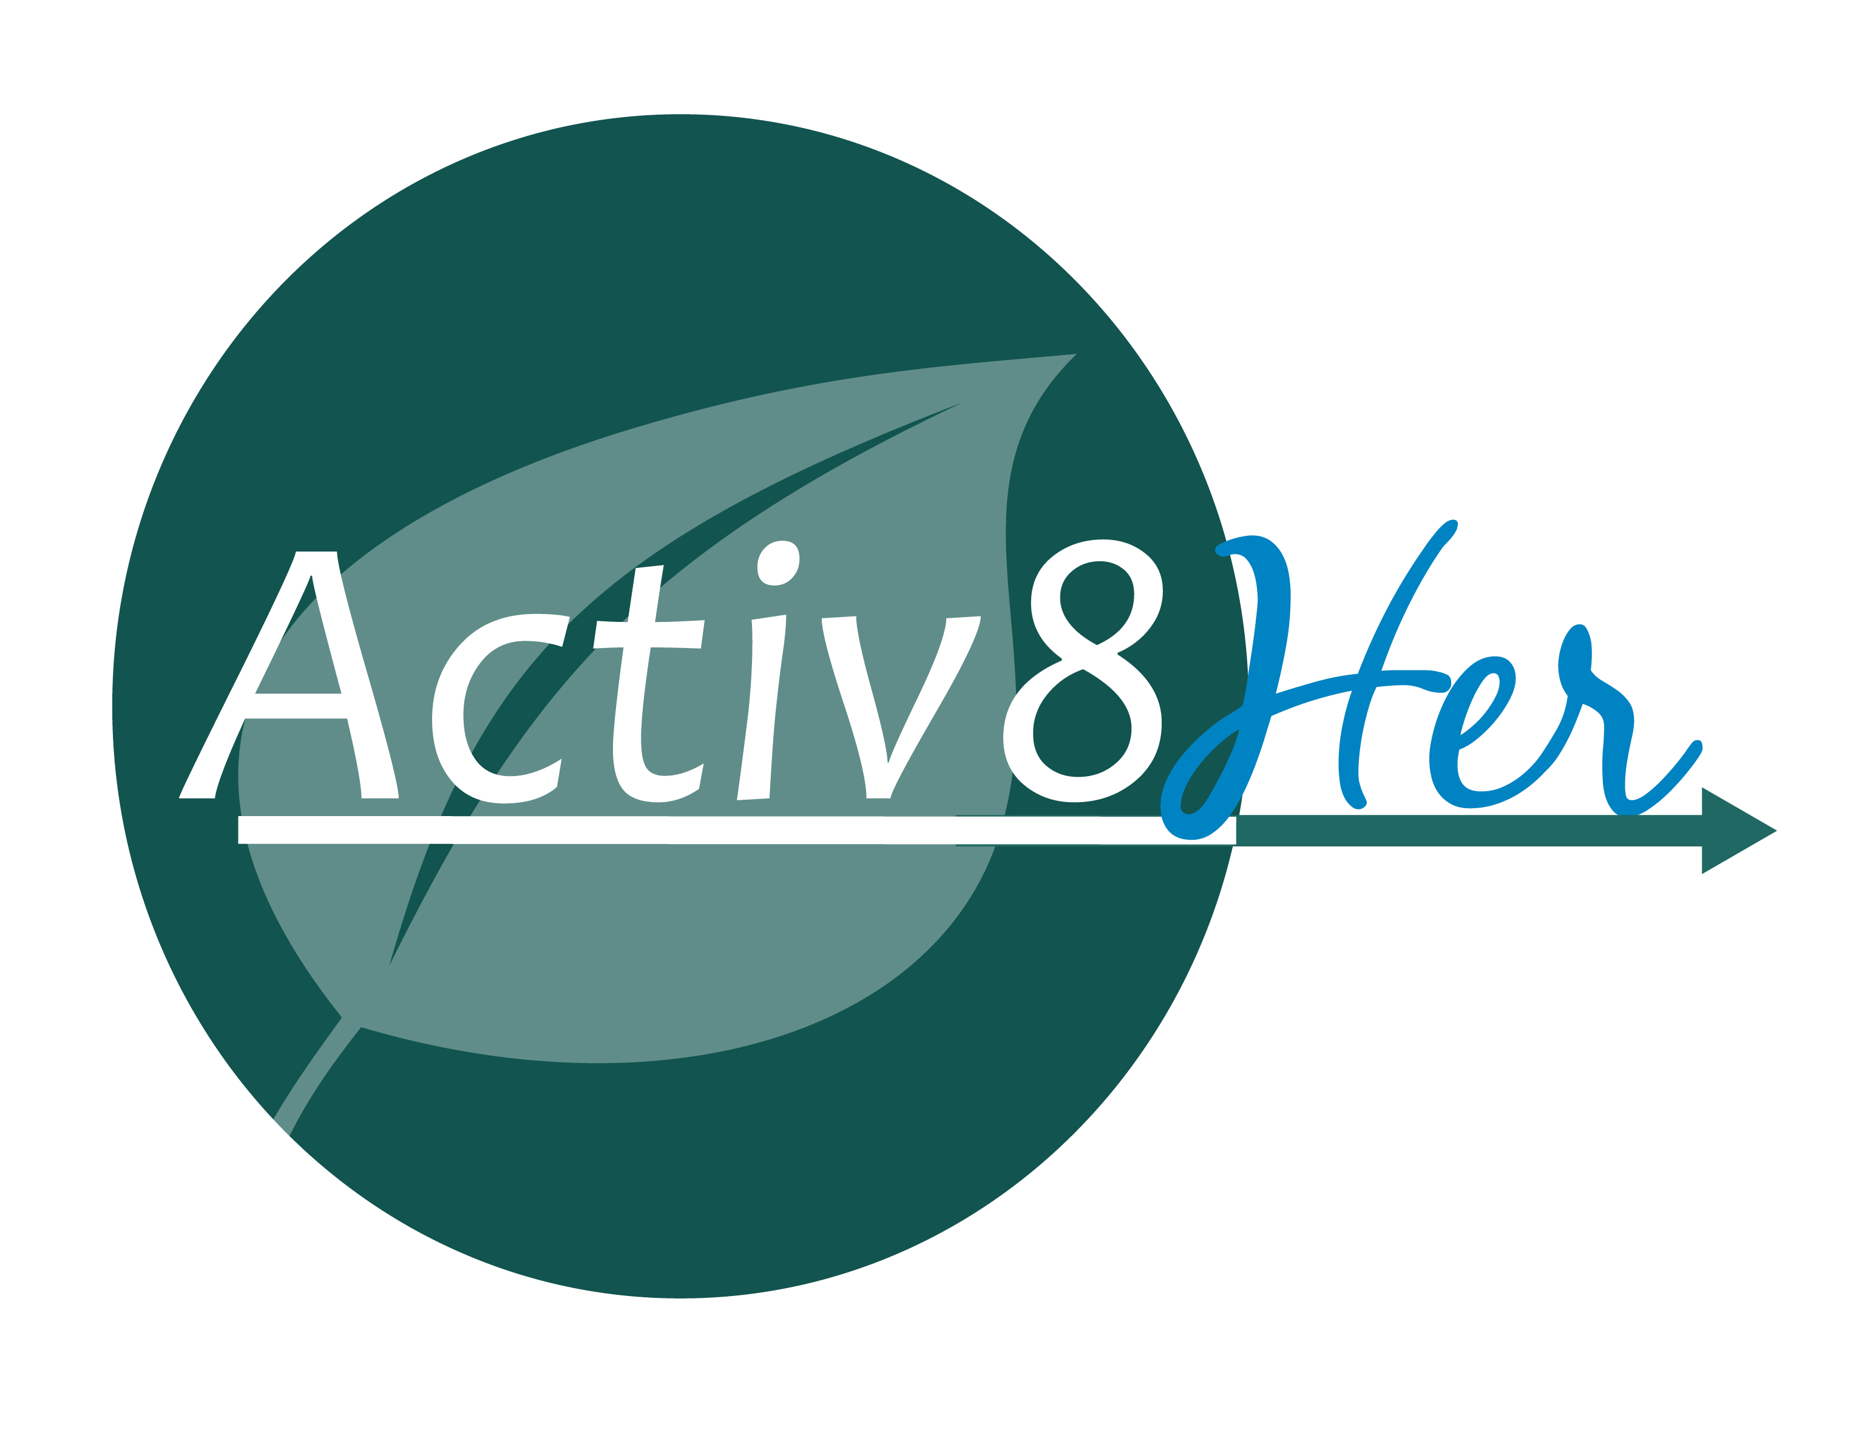#IAM- Beautiful**

***Second meeting ideas***

1. Review from the first meeting and do a photo shoot.
   1. Set up a black backdrop (can just be a sheet or black poster board)
   2. Have the words, #IAM-Beautiful on a whiteboard and ask the ladies to finish the sentence: #IAM Beautiful because:
   3. Take a photo of each woman holding her whiteboard.
2. Continue the discussion of purity and how it relates to beauty by discussing the Titus 2 Woman.

3) These questions are from [Girl Talk](http://www.amazon.com/Girl-Talk-Mother-Daughter-Conversations-Womanhood/dp/1581345100/ref=sr_1_1?s=books&ie=UTF8&qid=1363720172&sr=1-1&keywords=girl+talk" \t "_blank) by Carolyn Mahaney & Nicole Mahaney Whitacre (pages 134-135).

Give as a quiz, then discuss; or just use for group discussion.  Encourage your group to dig deep for the honest answer. See Activ8Her’s monthly pdf of scriptures, #IAM Beautiful, to serve as a foundation for your discussion.

1.  Do I spend more time each day caring for my personal appearance than I do in Bible study, prayer and worship?

2.  Do I spend excessive money on clothes, hair, and makeup, or is it an amount that is God honoring?

3.  Do I want to lose weight to “feel better about myself,” or do I desire to be self-disciplined for the glory of God?

4.  Am I on a quest for thinness to impress others, or do I seek to cultivate eating habits that honor God?

5.  Do I exercise to try to create or maintain a good figure, or do I exercise to strengthen my body for God's service?

6.  Is there anything about my appearance that I wish I could change, or am I grateful to God for the way He created me?

7.  Am I jealous of the appearance of other girls, or am I truly glad when I observe girls who are more physically attractive than I?

8.  Do I covet the wardrobe of others, or do I genuinely rejoice when other girls are able to afford and purchase new clothing?

9.  When I attend an activity, do I sinfully compare myself with others, or do I ask God to show me whom to love and how to do it?

10.  Do I ever dress immodestly or with the intent of drawing attention to myself, or do I always dress in a manner that pleases God?